R
EMOVE PEOPLE

to the
ASSEMBLY AREA
A

LERT THE FIRE SERVICE

break manual call point

C

ONFINE FIRE & SMOKE

close doors and windows
E

from immediate danger

IN CASE OF FIRE
(if safe to do so)
call 000
VACUATE
EVACUATION SIGN and DIAGRAM
Premises Name


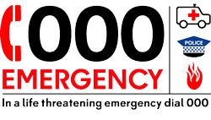
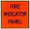
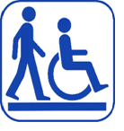

In an emergency dial 000
YOU ARE HERE
Mobility impaired persons
should evacuate
immediately on hearing
the fire alarm assisted
by a nominated person.
AA
MANUAL CALL POINT

EXIT
ASSEMBLY AREA

PATH OF EXIT
EXTINGUISHER
FIRE HOSE REEL
FIRE INDICATOR PANEL
ALTERNATE PATH
MANUAL CALL POINT
AA

